

|  |  |  |  |
| --- | --- | --- | --- |
| **New Arrival** | | | |
|  |  |  |  |

|  |  |  |  |
| --- | --- | --- | --- |
| **Trending** | | | |
|  |  |  |  |

**Logo**



**Cart**

**Sign In | Join**



**Promo**

Search



All Category

**Women**

**Accessories**

**Kids**

**Men**

**Contact Us**

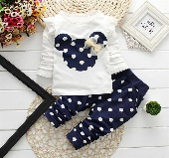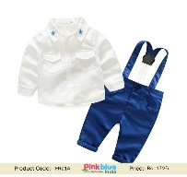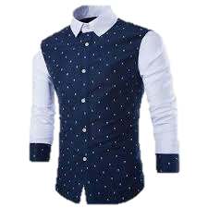

|  |  |  |  |
| --- | --- | --- | --- |
| **ABOUT US** | **WHAT’S IN STORE** | **INFORMATION** | **FOLLOWS** |
| **Sri Lanka’s biggest fashion chain offers a wide range of clothes and accessories for Men, Women and Kids.** | **Women**  **Men**  **Kids**  **Accessories** | **About Us**  **Promo**  **Contact Us**  **Store Locators** |  |

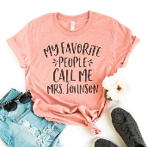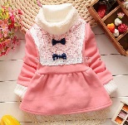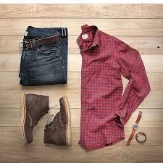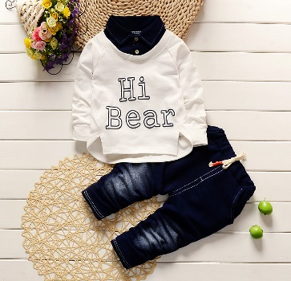

US $2.22

**Footer**



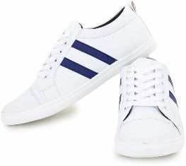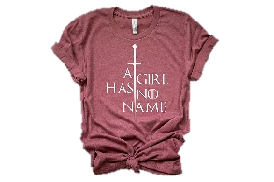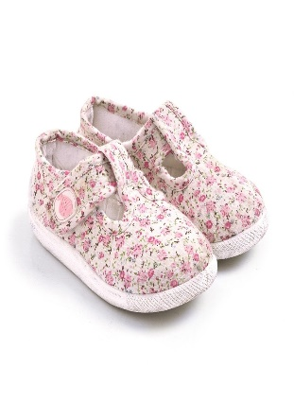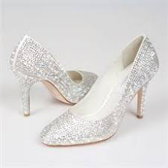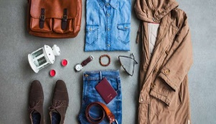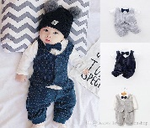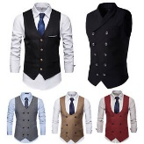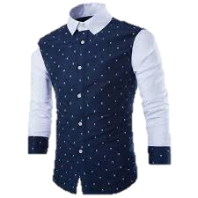

US $2.22

US $2.22

US $2.22

US $2.22

US $2.22

US $2.22

US $2.22

US $2.22

US $2.22

US $2.22

US $2.22

US $2.22

US $2.22

US $2.22

US $2.22

US $3.22

**Logo**

|  |  |  |  |  |  |  |  |  |
| --- | --- | --- | --- | --- | --- | --- | --- | --- |
| Category See All | Super Deal | Best Buy | | Promo | | Home | |  |
| Men |  | | | | | | | |
| Women |
| kids |  | |  | |  | |  | |
| Shoes |
| Accessories |
| Phone |  | |  | |  | |  | |
| Men |
| Women |
| kids |  | |  | |  | |  | |
| Shoes |
| Accessories |
|  |  | |  | |  | |  | |
|  |  | |  | |  | |  | |

Footer1

**Banner images**

Search



All Category

**Cart**

**Sign In | Join**



tabs

**Footer**



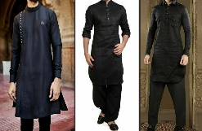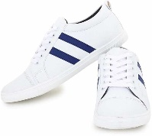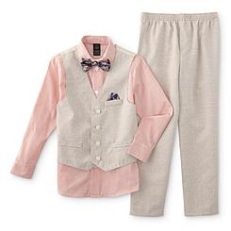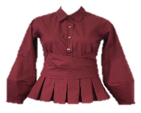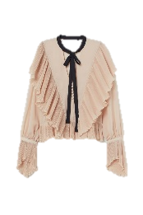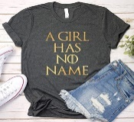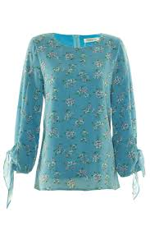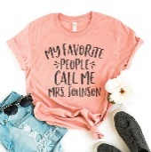

**Sign In | Join**



**Logo**

US $2.22

US $2.22

|  |  |  |  |  |  |  |  |  |  |  |
| --- | --- | --- | --- | --- | --- | --- | --- | --- | --- | --- |
| Category See All | Super Deal | Best Buy | | | Promo | | | Home | |  |
| Men |  | | | | | | | | |
| Women |
| Kids |
| Phone |  | | |  | | |  | | |
| Laptop |
| Shoes |
| Men |  | |  | | |  | | |  | |
| Women |
| Kids |
| Phone |  | |  | | |  | | |  | |
| Laptop |
| Shoes |
| Men |  | |  | | |  | | |  | |
| Men |
| Women |
| Kids |  | |  | | |  | | |  | |
| Phone |
| Laptop |
|  |  | |  | | |  | | |  | |

Footer1

US $3.22

US $2.22

US $2.22

US $2.22

US $2.22

US $2.22

US $2.22

US $2.22

US $2.22

US $2.22

US $2.22

US $2.22

US $2.22

US $2.22

US $2.22

US $2.22

US $2.22

**Banner images**

Search



All Category

**Cart**

tabs